**ASSIGNMENT-10**

Ques 1: Create a container for the below bash script(**pomodoro.sh**).

1. Create a Dockerfile
2. Create a Docker Image
3. Push the image to the docker hub
4. Pull it and test it.

Find the script here <https://github.com/DARK-art108/Bash-Scripts>

**Step-1: Create a DockerFile**

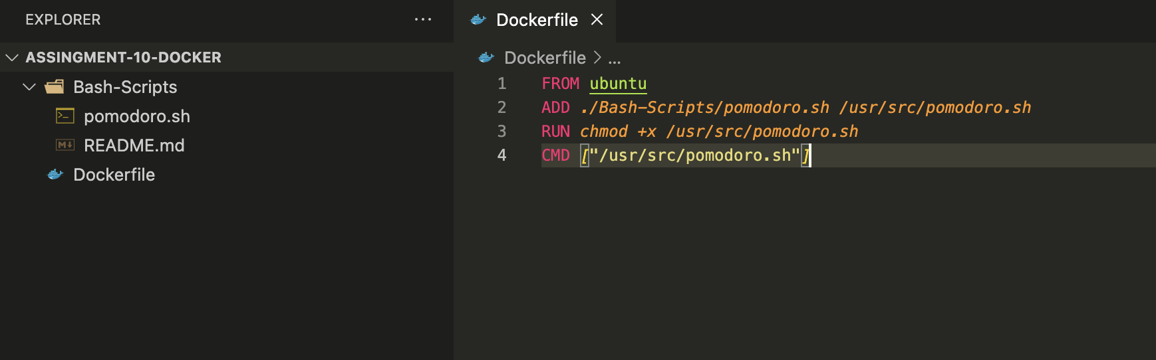

**Step-2: Build a Docker Image**

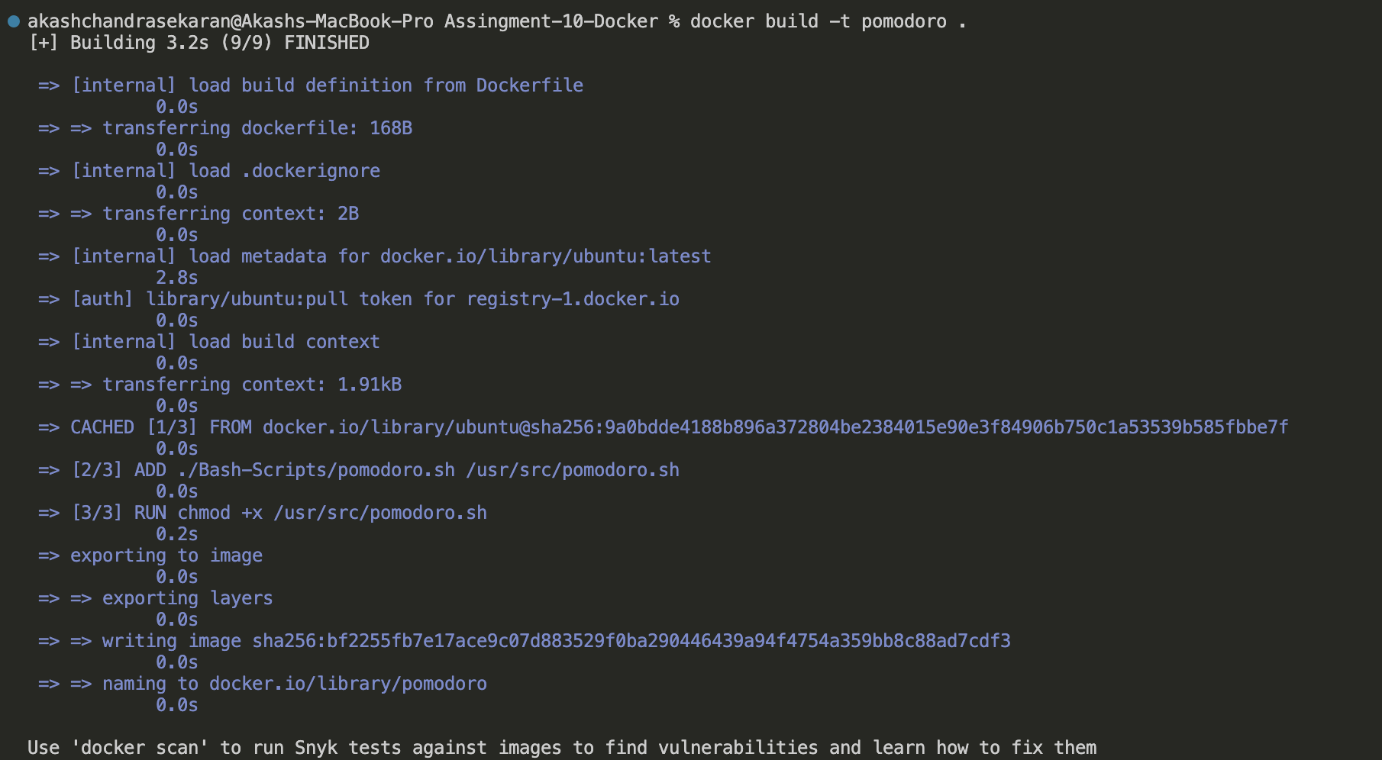

**Step-3: Push the image to the docker hub**

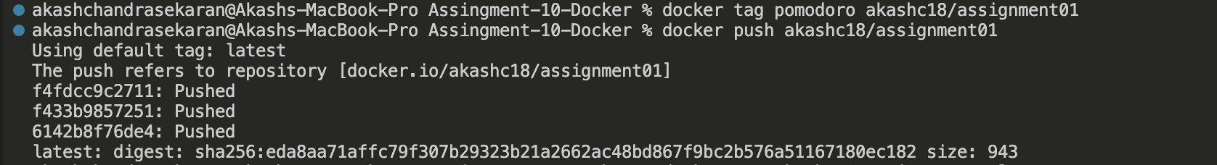

**Step-4: Pull the image and test it.**

**Result:**

